# Overview

In this guided practice you will create the **Research** domain for the Charlotte location as a child domain of the **ABSCorp** (abscorp.com) domain.

# Objectives

* Be able to install Active Directory as a child domain, additional domain controller, and a new domain.
* Be able to verify the installation of Active Directory.

# Prerequisites

Guided practice - **Installing Active Directory in a New Forest** is complete.

# Scenario

The members of the research domain would like to have a stricter password policy than the corporate domain and have decided to create a child domain to implement this requirement.

# Tasks

## Verifying connectivity to the root domain

Verify that the **CIS256-DC1** and **CIS256-RTR** virtual machines must be **running**.

1. **Start** the **CIS256-DC2** and **logon** as the **administrator**.
2. **Verify** that you can **connect** to the **ABSDC1** (CIS256-DC1) by pinging its address. Trouble shoot as needed before proceeding.
3. **Verify** your **DNS client** is configured to use the **ABSDC1** server.
4. Open a **PowerShell** prompt with administrative rights.
5. Type the following command to verify that you can resolve names in the abscorp.com domain:

Resolve-Dnsname ABSDC1.abscorp.com

1. **Join** your server to the **ABSCorp**.**com** domain. Restart when prompted.

## Installing Active Directory

1. **Open** **Server Manager** and **start** the **Active Directory Configuration wizard** like you did in the previous guided practice.
2. 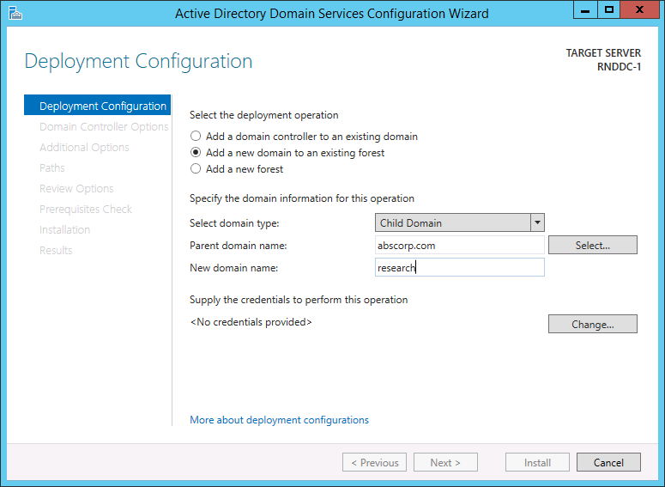On the **Deployment Configuration** page of the wizard, select **Add a new domain to an existing forest** radio button, leave the domain type as **Child Domain**, type **abscorp.com** in the **Parent domain** **name** text box, and **research** in the **New domain** name text box as shown in the figure below. **Click** the **Next** button.
3. On the **Domain Controller options** page of the wizard, **verify:**
   1. The **Domain** **functional** **level** is **Windows Server 2016**
   2. The **Domain Name System (DNS)** server and **Global Catalog (GC)** checkboxes are **selected**
   3. The **Site name:** is **Default-First-Site-Name**
4. Type **Password1** in the **Password** and **Confirm** password text boxes. **Click** the **Next** button.
5. On the **DNS Options** page of the wizard, **verify** the **Credentials** for delegation creation are **abscorp\absadmin** and **Click** the **Next** button.
6. On the **Additional Options** page of the wizard, verify that **RESEARCH** is listed in the **NetBIOS domain name**: textbox and **click** the **Next** button.
7. On the **Paths** page of the wizard, note the location of the Database, Log Files, and SYSVOL folder and **click** the **Next** button.
8. On the **Review Options** page of the wizard, review the settings and **click** the **Next** button.
9. On the **Prerequisites** **Check** page of the wizard **read** the **warnings** and **click** the **Install** button.
10. Reboot your system when done.

## Verify the installation of Active Directory

Logon to your system as the administrator and verify that Active Directory was properly installed by verifying the following:

1. Active Directory Tools were installed.
   1. AD Users and Computers
   2. AD Sites and Services
2. The Sysvol share was created.
3. The Active Directory database is in the proper location.
4. DNS has the required service locator records.
5. Review the logs in the Event Viewer and address any errors.
6. Run the dcdiag command and resolve any relevant errors.

## Additional Configurations

### Creating an administrative account

Create the following account in Active Directory:

1. **Create** a user **account** named **RNDAdmin**. Set the password to **Password1**.
2. **Add** **RNDAdmin** to the **Domain Admins**

### Additional DNS Configurations

1. **Add** a **primary** AD integrated **reverse** **lookup** zone for the **10.1.2.0/24** network.
2. Update your pointer record so that it appears in this zone.

### Installing and Configuring DHCP

Install DHCP on your server to support clients that will be connected to the local network name the scope after the location and issue IP addresses from .10 to .240 for your local subnet.

* Log in with **RNDAdmin** account.
* Authorize with **ABSAdmin** account.

## JOIN LT1 CLIENT TO ABSCORP DOMAIN

1. Connect the **CIS256-Client2** to the **Charlotte** virtual switch.
2. Verify that DHCP is working and the client gets a valid address on the Charlotte subnet.
3. The KMS server for ECPI is located at **10.10.6.20**. In **Windows PowerShell (admin)**, issue the following commands to activate the Windows server systems.

slmgr /skms 10.10.6.20

slmgr /ato

The expected response is **Product activated successfully**.

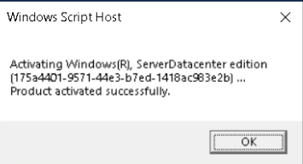

1. If the response from **slmgr /ato** is ***The activation server determined that the specified product key could not be used***, issue the following commands

slmgr /ipk WMDGN-G9PQG-XVVXX-R3X43-63DFG

slmgr /ato

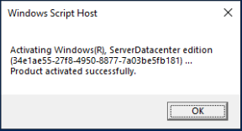

1. Join the VM to the **ABSCorp.com** domain.
2. Add **Domain Users** to the **Remote Desktop Users** group.
3. Verify that you can log in with your non-admin account.
4. Verify that the client can ping hosts on the internal network and on the Internet.

# Submission Requirements

1. **Download** the **grading** **script** from the assignment page to the **C:\Scripts** folder.
2. Check your lab by running the following command:

Invoke-Pester -Path C:\Scripts\GP05-Creating_a_Child_ Domain.test.ps1

**Note**: You will see a security warning when running the script. Enter **R** to run the script.

If you want to see more detail, add **-Output Detailed** to the command. This may assist you with troubleshooting

Path C:\Scripts\GP05-Creating_a_Child_ Domain.test.ps1 -Output Detailed

1. You should not see any red in the output. Red in the PowerShell way of telling you that an error condition exists. Most of the time, the output will tell you what is wrong. If it is not obvious, contact your teacher and ask for assistance. You will be learning PowerShell during this term. **Correct** any **errors** you may have and run the script until all the output has no red. You should see the output like the images below.

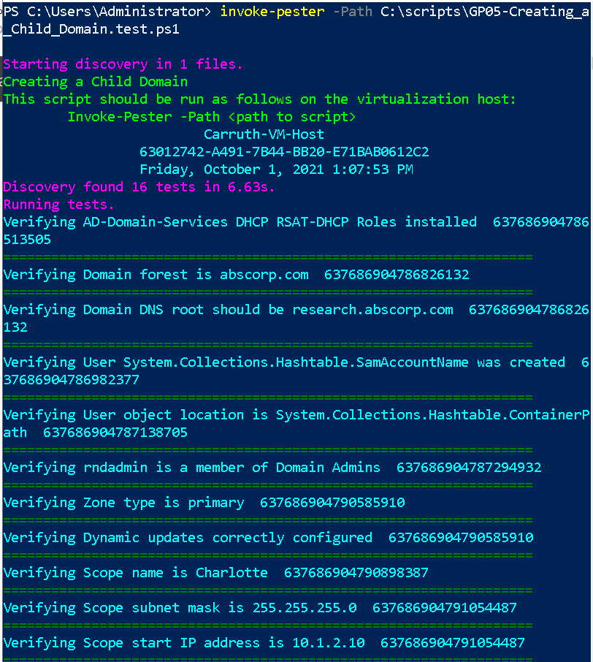

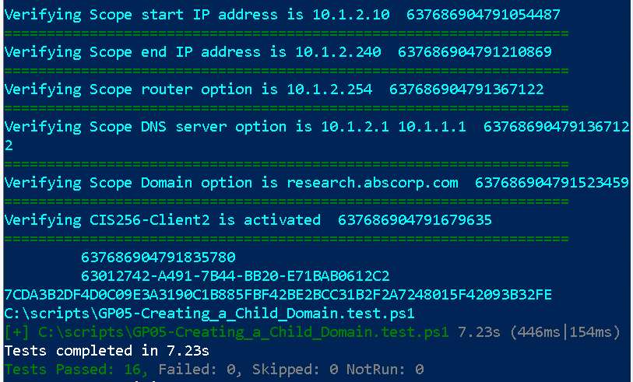

1. Capture a snippet that shows the PowerShell Command and all its output. If you must use more than one snippet to capture the output, you must have at least **one line of overlap** in the snippets. The text in the snippets **must be legible** when pasted into the Word document. Paste the snippet(s) into a **new** **Word** **document.**
2. **Upload** the **document** in the submission area for the assignment.